Williamstown Little Athletics Centre Inc.

Centre Handbook

Season 2020/21

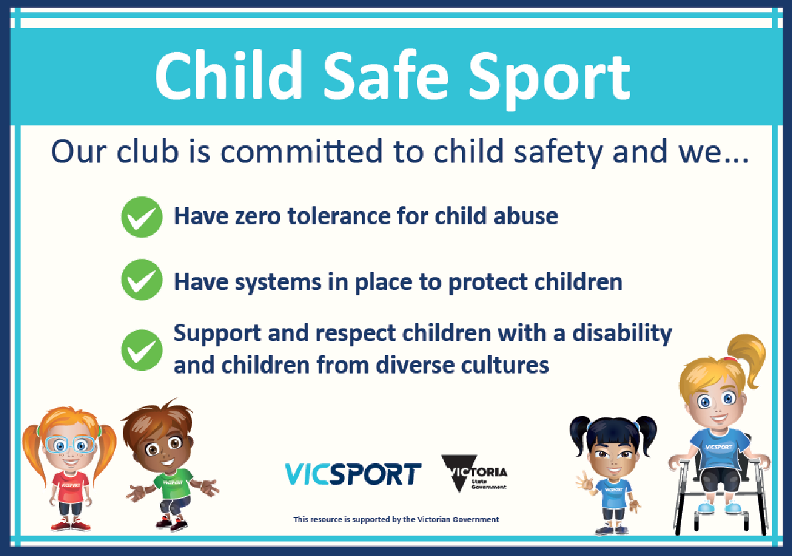

A0061672P
Centre Number 9
Commenced 4/10/1967
53 years of family, fun and fitness

Williamston Little Athletics Centre Sponsors

Commonwealth Bank

Yarraville Shoe Company
www.therunningcompany.com.au/yarraville/

Committee Welcome

Welcome to 2020/21 season, our 53rd as a competing centre at little athletics. We are looking forward to some exciting new changes and innovations to ensure all athletes can compete in a safe and family friendly environment.

Coaching will be offered on Tuesday and Thursday 4:30- 5:30 pm. You will need to register for this via Team App. U7 – U8’s will receive some coaching while waiting to have their turn at particular events. This will assist with minimising down time on a Saturday and ensure athletes are using the correct technique.
It is essential that all parents register with Team App this year via their smart phones as this is the main source of communication to parents and we need to ensure we keep within Covid regulations, so pre registering for events may be necessary. You will need to have access to “Players and Officials' group. Event cancellations, weekly competition updates, training and state and regional team information will be communicated via Team App.

Sign up for duty roster will be done on Sign up genius. Links for this are on team app or click here:

https://www.signupgenius.com/index.cfm?go=c.SignUpSearch&eid=0EC1C8DFFCC8FD6D&cs=09B6BADE8FC58B137B7C640F5BB29BBA&sortby=startdate

You will be required to select 5 duties. This is required for your child/children to participate in club championship day. There are helpful videos on Team app to assist you learn the roles required.

On the following pages you will see that we have some gaps on the committee currently and moving into next season. With many of the current committee’s children finishing Little Athletics we will be looking to fill many positions at our next AGM. For the current season we are looking for a President, fund raising manager , secretary and general committee members. If you would like any further information on the responsibilities of these roles please contact myself or any of the other committee members.

I hope you all enjoy the season ahead, and we welcome feedback and comments via our website. I would encourage all parents to become involved as coaches, age group managers and getting to know other parents through the duty roster. This season may require some flexibility and adaptability as we have all learned though this year that we don’t know what’s ahead! All parents will need to be responsible for following State Government guidelines regarding social distancing and mask use. Together we all can make the 2020/21 season successful and enjoyable for everyone.

WLAC- Committee

Williamstown History

In 1967, the Williamstown Little Athletics Centre (WLAC) was formed after a committed group of parents took a group of local children to a Little Athletics carnival in Corio. This was the start of centre number 9 (ninth little athletics centre established in Australia) – the Williamstown Little Athletics Centre. Our first season of competition was held at the Newport Football Ground, in Market Street, not far from the Newport train station. During the first season, the WLAC had 13 clubs and a total of 982 children U9 to U12.

In 1969, the Altona Little Athletics Centre was formed by a brake away group from our centre. The WLAC was left with 549 children U9 to U12 competing for 7 clubs.
- North State
- Westport
- Sacred Heart
- Williamstown State
- St May’s
- Yarraville West
- Williamstown Youth Centre

In 1991 the WLAC moves from our original grass oval in Market Street to the new Newport Park Athletics Track, where we are today, and for the first time our centre now has an all-weather synthetic track.

By 1996 the Westport club is the only l club left to retain its original name. This club structure was retained until 2015, when under the advice from Little Athletics Victoria the WLAC decides to fold the clubs and compete as a new one centre for the first time. In October 2017, the WLAC celebrated its 50th year!

Little Athletics Victoria Mission Statement
Through the enjoyment of Athletics, develop positive attitudes and a healthy lifestyle for our children, families and community.

Acknowledgment of voluntary service
Over the history of the Williamstown Little Athletics Centre there have been several people who have shown a great commitment of time and energy to the Centre, for the benefit of all children participating in Little Athletics. The Centre acknowledges and thanks these people through the presentation of Life Membership and Distinguished Service Awards.

Williamstown Little Athletics Centre Life Members
1978 Jim Jamieson (Deceased)
1981 Marion Cochrane, Frank Cochrane (Deceased)
Tim Lowden, Joyce Lowden (Deceased)
Bill Humphries (Deceased)
1985 Elaine Sanderson
1987 Phil Gillan (Deceased)
1988 Frances Larson, Ken Schwartz (Deceased)
1992 Christine Crofton
1994 Kay Reay, Jeff Scoble
1995 Lorraine Amezquita
1996 Susan Silke, Julie Scoble
2001 Michael Shacklock
2008 Heather Shaw
2009 Majella Stone
2010 Terri Buttigieg
2011 Sharon Hancock
2015 Paul Lynch

Distinguished Service Awards
1987 Jan Stewart, Alan Gittins
1988 Jennine Harrison
1999 Ted Hudson
2011 Geoff Boyce
2012 Chris Buttigieg-Clarke
2014 Gill Hardeman, Craig Hardeman, Lorraine Cockram
2015 John Gilbert, Samantha Cross

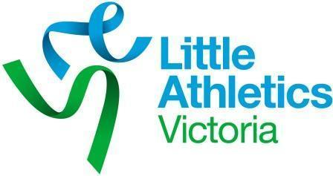

History of Little Athletics
Little Athletics evolved, like most voluntary community organisations, through the mind and conscience of one man. Trevor Billingham followed the pattern set by many pioneers in the field of community service. He recognised a need and introduced an idea designed to meet that need.

On an October day in 1963 three boys turned up at an athletics meeting in Geelong. They were ready to compete. On approaching an official they were told that they were too young to take part. That official was Trevor Billingham.

The disappointment, evident in the boys, left a marked impression on his mind. The thought was forgotten; it came alive again several months later. At a coaching clinic designed for secondary school students it was noted that most children were of primary school age.

Reminded of his earlier experience, Trevor Billingham had an idea. The answer to the need expressed in the children would be a simple Saturday morning competition. On the first Saturday of October 1964, he met with a small group of children on a Geelong oval. They took part in a short program of running events.

From that simple beginning, athletics for Under 12 boys and girls developed at a phenomenal rate.

Little Athletics was born and on the move
Little Athletics created tremendous interest; by 1967 the Victorian Little Athletics Association was formed. This was the same year the Williamstown Little Athletics Centre commenced.

The Australian Little Athletics Union was formed in Perth on the 31 March 1972. Victoria, New South Wales, Northern Territory & Western Australia were the founding members.

Little Athletics Victoria now has over 15,000 members competing on a weekly basis at 103 Centre’s across Victoria.

About Williamstown Little Athletics Centre (WLAC)

Williamstown Little Athletics Centre is a member of Little Athletics Victoria. Approximately 300 local children participate in Little Athletics at WLAC.

WLAC was started in 1967 and was the ninth Centre to start, which is why our centre number is 9. WLAC runs events for children from Under 6 to Under 16.

Officeholders
Williamstown Little Athletics Centre Officeholders.

OFFICE HOLDERS
President | Vacant  williamstownvp@lavic.com.au
Vice President | Ashley Sandison  williamstownpresident@lavic.com.au
Secretary | Rachelle Burbidge  williamstown@lavic.com.au
Treasurer | Ben McInnes  willitreasurer@lavic.com.au
Communication Manager | Rachelle Burbidge  williamstown@lavic.com.au
Registrar  and Chief Official | Russell Dmytrenko  williamstownregistrar@lavic.com.au
Fundraising Manager | Vacant
Coaching Coordinator | Anne Rossie
Results Managers | Peter Parks  williamstown@lavic.com.au
WMR representative | Karen Boase  williamstown@lavic.com.au
Uniform Coordinator | Laura Capitanio  williamstown@lavic.com.au
The Williamstown Centre Executive Committee is made up of volunteers, who work together to coordinate and conduct the seasonal Little Athletics program, including the weekly program, external events, special internal events, Centre Championships and Cross Country.

Centre committee meetings are held monthly at 7:30pm, usually on the second Wednesday of every month at Newport Park. All members are welcome to attend, if you would like to attend please speak to a committee member for details.

Correspondence
Please send all correspondence to:
The Secretary
Williamstown Little Athletics Centre
P.O. Box 17
Williamstown VIC 3016
Email: williamstown@lavic.com.au

The WLAC website
www.willylac.com.au
Visit our website and discover a wealth of information on:
- Results published weekly
- Centre Policies
- Upcoming events
- Centre Records

The WLAC Team App
https://williamstownlittleathletics.teamapp.com

- Last minute program cancelations due to weather
- Event updates
- sign up rosters for parent duty
- registration of athlete attendance (new Covid-19 policy to be confirmed)

Layout of the Williamstown Little Athletics Track
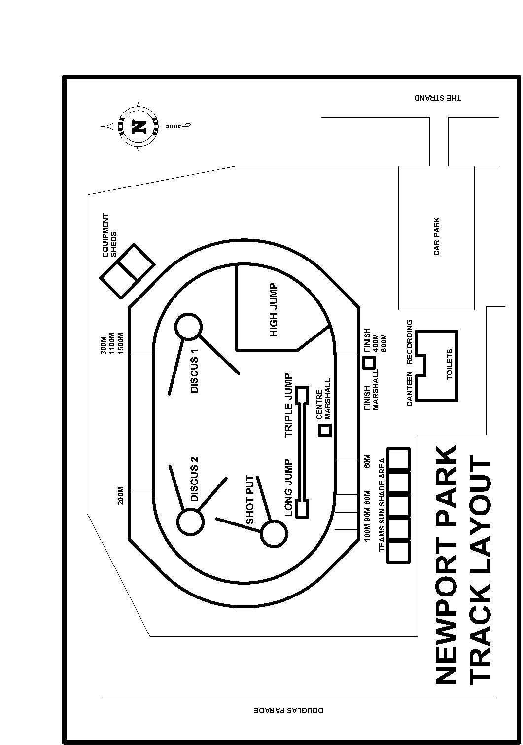

The Summer Season: Track and Field

Season Commences:

Saturday Nov 21 Come and Try Day (need to register on Team app if attending) -No Points
Saturday Nov 28 First official day- Points.

This season make up will be determined by Covid restrictions. All dates in this handbook are subject to change due to the uncertainty surrounding this season. Stay up to date via Team App and the LAVIC website

Age groups for Season 2020/21
Age Group Calculator 2020-21 Season
 | 2005 | 2006 |  | 2007 |  | 2008 |  | 2009 |  | 2010 |  | 2011 |  | 2012 |  | 2013 |  | 2014 |  | 2015 | 20166
Jan | U 16 |  | U 15 |  | U 14 |  | U13 |  | U12 |  | U11 |  | U10 |  | U9 |  | U8 |  | U7 | U6 | U6
Feb | U 16 |  | U 15 |  | U 14 |  | U13 |  | U12 |  | U11 |  | U10 |  | U9 |  | U8 |  | U7 | U6 | U6
Mar | U 16 |  | U 15 |  | U 14 |  | U13 |  | U12 |  | U11 |  | U10 |  | U9 |  | U8 |  | U7 | U6 | U6
Apr | U 16 |  | U 15 |  | U 14 |  | U13 |  | U12 |  | U11 |  | U10 |  | U9 |  | U8 |  | U7 | U6 | U6
May | U 16 |  | U 15 |  | U 14 |  | U13 |  | U12 |  | U11 |  | U10 |  | U9 |  | U8 |  | U7 | U6 | U6
Jun | U 16 |  | U 15 |  | U 14 |  | U13 |  | U12 |  | U11 |  | U10 |  | U9 |  | U8 |  | U7 | U6 | U6
Jul | U 16 |  | U 15 |  | U 14 |  | U13 |  | U12 |  | U11 |  | U10 |  | U9 |  | U8 |  | U7 | U6
Aug | U 16 |  | U 15 |  | U 14 |  | U13 |  | U12 |  | U11 |  | U10 |  | U9 |  | U8 |  | U7 | U6
Sep | U 16 |  | U 15 |  | U 14 |  | U13 |  | U12 |  | U11 |  | U10 |  | U9 |  | U8 |  | U7 | U6
Oct | U 16 |  | U 15 |  | U 14 |  | U13 |  | U12 |  | U11 |  | U10 |  | U9 |  | U8 |  | U7 | U6
Nov | U 16 |  | U 15 |  | U 14 |  | U13 |  | U12 |  | U11 |  | U10 |  | U9 |  | U8 |  | U7 | U6
Dec | U 16 |  | U 15 |  | U 14 |  | U13 |  | U12 |  | U11 |  | U10 |  | U9 |  | U8 |  | U7 | U6

Normal weekly events
The following events are considered normal weekly events

Discipline | U6 | U7 | U8 | U9 | U10 | U11 | U12 | U13 | U14 | U15 | U16
On Track | X
70m | X | X | X | X | X
100m | X | X | X | X | X | X | X | X | X | X | X
200m | X | X | X | X | X | X | X | X | X | X | X
400m | 300m | X | X | X | X | X | X | X | X | X | X
800m |  |  |  | _{X} | X | X | X | X | X | X | X
1500m |  |  |  |  |  | X | X | X | X | X | X
60mH |  | X | X | X | X
80mH |  |  |  |  |  | X | X | X | G
90mH |  |  |  |  |  |  |  |  | B | G | G
100mH |  |  |  |  |  |  |  |  |  | B | B
200mH/300mH |  |  |  |  |  |  |  | _{200mH} | _{200mH} | _{300mH} | _{300mH}
Long Jump | X | X | X | X | X | X | X | X | X | X | X
HighJump Scissor | _{Skill} | _{Skill} | X | X | X
High Jump |  |  |  |  |  | X | X | X | X | X | X
Triple Jump |  |  |  |  |  | X | X | X | X | X | X
Discus | X | X | X | X | X | X | X | X | X | X | X
Shot Put | X | X | X | X | X | X | X | X | X | X | X
Javelin |  |  |  |  |  | X | X | X | X | X | X

Legend: X - Both Genders, G –Girls, B –Boys, Skill – vertical jump training
The table below summarises the ideal number of events for each age group and gender for all weekly programs. In 2020-21 will have to be more flexible than previous seasons however we will endeavour to give consideration to balance out the season for all age groups and genders across each of the available track and field events. This allows athletes to compete in their preferred events while also encouraging them to have a go at events they may not like as much.

Event | U7 |  | U8 |  | U9 |  | U10 |  | U11 |  | U12 |  | U13 |  | U14 |  | U15
 | Boys | Girls | Boys | Girls | Boys | Girls | Boys | Girls | Boys | Girls | Boys | Girls | Boys | Girls | Boys | Girls | Boys | Girls
50m | 3 | 3 | 3 | 3 | 0 | 0
70m | 3 | 3 | 3 | 3 | 4 | 4 | 4 | 4
100m | 4 | 4 | 4 | 4 | 5 | 5 | 5 | 5 | 5 | 5 | 5 | 5 | 6 | 6 | 6 | 6 | 6 | 6
200m | 3 | 3 | 3 | 3 | 5 | 5 | 5 | 5 | 5 | 5 | 5 | 5 | 5 | 5 | 5 | 5 | 5 | 5
400m | 4 | 4 | 4 | 4 | 4 | 4 | 4 | 4 | 3 | 3 | 3 | 3 | 5 | 5 | 5 | 5 | 5 | 5
800m |  |  |  |  | 2 | 2 | 2 | 2 | 4 | 4 | 4 | 4 | 4 | 4 | 4 | 4 | 4 | 4
1500m |  |  |  |  |  |  |  |  | 3 | 3 | 3 | 3 | 4 | 4 | 4 | 4 | 4 | 4
60mH | 7 | 7 | 7 | 7 | 4 | 4 | 4 | 4 | 4 | 4
80mH |  |  |  |  |  |  |  |  |  |  | 4 | 4 | 7 | 7 |  | 7
90mH |  |  |  |  |  |  |  |  |  |  |  |  |  |  | 7 |  |  | 7
100mH |  |  |  |  |  |  |  |  |  |  |  |  |  |  |  |  | 7
200mH |  |  |  |  |  |  |  |  |  |  |  |  | 3 | 3 | 3 | 3
300mH |  |  |  |  |  |  |  |  |  |  |  |  |  |  |  |  | 3 | 3
Triple Jump |  |  |  |  |  |  |  |  | 4 | 4 | 4 | 4 | 4 | 4 | 4 | 4 | 4 | 4
Long Jump | 7 | 7 | 7 | 7 | 7 | 7 | 7 | 7 | 4 | 4 | 4 | 4 | 4 | 4 | 4 | 4 | 4 | 4
High Jump | 5 | 5 | 5 | 5 | 5 | 5 | 5 | 5 | 4 | 4 | 4 | 4 | 4 | 4 | 4 | 4 | 4 | 4
Discus | 5 | 5 | 6 | 6 | 6 | 6 | 6 | 6 | 4 | 4 | 4 | 4 | 5 | 5 | 5 | 5 | 5 | 5
Shot Put | 7 | 7 | 6 | 6 | 6 | 6 | 6 | 6 | 4 | 4 | 4 | 4 | 5 | 5 | 5 | 5 | 4 | 4
Javelin |  |  |  |  |  |  |  |  | 4 | 4 | 4 | 4 | 4 | 4 | 4 | 4 | 5 | 5
Total Field | 24 | 24 | 24 | 24 | 24 | 24 | 24 | 24 | 24 | 24 | 24 | 24 | 26 | 26 | 26 | 26 | 26 | 26
Total Track | 24 | 24 | 24 | 24 | 24 | 24 | 24 | 24 | 24 | 24 | 24 | 24 | 34 | 34 | 34 | 34 | 34 | 34
Total Events | 48 | 48 | 48 | 48 | 48 | 48 | 48 | 48 | 48 | 48 | 48 | 48 | 60 | 60 | 60 | 60 | 60 | 60

The Winter Season: Cross Country

Cross Country running is an important part of Little Athletics. It is an ideal way for those athletes who like the longer distances to enjoy a different style of competition. Further, participating in the program is beneficial for building strength and stamina for the next season of track and field events. Without a parent to assist we will not be able to provide the following:

Start Time and location
9.30am start at various venues in Western Region. We combine with other centres in the region.
Williamstown ‘home’ venue is Newport Lakes Park located off Lakes Drive, Newport (just off Mason Street).

All children from Under 6 to Open may participate.
Distances run at Williamstown are:

Age Group | Distance
U9-8 | 1000 metres
U9-10 | 1500 metres
U11-12 | 2000 metres
U13-16 | 3000 metres

Summer season WLAC registration covers athletes for the cross-country season. New members are welcome to join the WLAC cross-country season. A registration fee will apply.

Cross Country Season 2021
The 2021 Cross Country starting date will be confirmed in the New Year.

Centre Information

How to help at Little Athletics
Every parent is an important part of the Williamstown Little Athletics Community; without your help there would not be anyone to conduct the events for our children. During the Little Athletics Season, you will be asked to choose a duty.
Parents are required to participate in volunteer duties to ensure that their child is eligible for the centre championships and awards.
Sign up for duty roster will be done on Sign up Genius. Links for this are on team app or click here:

https://www.signupgenius.com/index.cfm?go=c.SignUpSearch&eid=0EC1C8DFFCC8FD6D&cs=09B6BADE8FC58B137B7C640F5BB29BBA&sortby=startdate

You will be required to select 5 duties.. There are helpful videos on Team app to assist you learn the roles required.

It is the parent’s responsibility on each competition day to sign the attendance sheet to confirm their duty. In the event a competition is cancelled due to bad weather the rostered parent’s duty will count towards the number required for their child to be eligible for centre championships. This number is usually 5 but is subject to change this season depending on the amount of weeks in the season.

There is an online program, available to all parents, to learn about officiating for their event. We encourage everyone to go on and complete the program specific to his or her chosen duty or just general information about assisting.

http://lavic.com.au/Education-Training/Officials

Enclosed footwear must be worn when completing duties.

Uniform
The correct Centre uniform must be worn when competing. It is important to ensure your uniform is correct when representing the centre at Regional and State competitions including Relays, Cross Country, Track and Field and Multi Event. Failure to meet the LA Vic requirements may result in disqualification.

Approved centre uniform
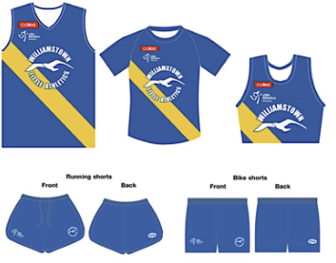

All athletes must wear the centre uniform inclusive of their registration patch.

WLAC apparel can be purchased from the Pavillion.Athletes may wear a second top underneath their Centre uniform top. If worn, the top must be plain and similar colour as the centre uniform.

Athletes may wear a second pair of shorts underneath their Centre shorts. If worn, they must be plain and the same colour as the Centre shorts colour or beige. Except for leggings permitted during Cross Country and Road Relay competitions, no part of the uniform will extend beyond the top of the knee (i.e. the knee must be completely visible). All shorts and leggings must be worn to cover the hipbones.

Leggings may be worn during Cross Country or Road Relay competitions only. If worn, they must be the WLAC approved leggings with no branding.

Failure to comply with uniform standards may result in an athlete being disqualified.

Steigen athletics socks are available for purchase also but not compulsory.

Footwear and Shoes
Footwear is compulsory for ALL athletes in ALL events. The wearing of footwear with blades or cleats constructed of hard plastic will not be permitted.
Spike shoes will only be permitted to be worn by the age groups and in the events listed in the following table:

Age Group | Track events | Field Events | Relays | Cross Country | Road Relays
U9-10 | No Spike Shoes allowed | No Spike Shoes allowed | No Spike Shoes allowed | No Spike Shoes allowed | No Spike Shoes allowed
U11-12 | All events run entirely in lanes | All events & Javelin | All events | No Spike Shoes allowed | No Spike Shoes allowed
U13-16 | All events except race walks | All jump events & Javelin | All events | No Spike Shoes allowed | No Spike Shoes allowed

The length of the spike must not exceed seven (7) mm. Specialist High Jump and Javelin footwear with heel spikes must not exceed seven (7) mm and may only be worn at these events. Only spike designs known as conical will be permitted. All spike shoes must be worn with all holes filled with a complete set of spikes with no more than two blanks/slugs installed.
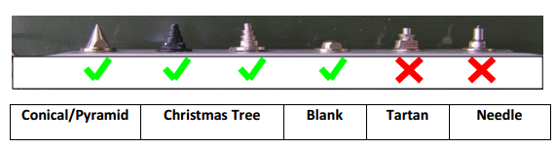

Spikes must only be worn on the track or at the field event while the athlete is competing, i.e. in the competition area. Normal footwear must be worn to and from the competition area and at all other times.

Improper or incorrect wearing of spike shoes by an athlete detected by officials will be referred to the Referee. Improper or incorrect wearing of spikes by an athlete detected by Officials shall be forced to compete in normal footwear.

Any athlete found to be using spikes in a manner likely to cause injury to any other competitor may be banned from wearing spikes for the remainder of the season.

Parental supervision
A parent or guardian must be in attendance at the Centre during all events. Any child without supervision may be withdrawn from competition until the adult returns.

First Aid
First Aid is of paramount importance at all Little Athletic events. Two St John’s Ambulance First Aiders will be in attendance at all weekly competitions.

Injury and Insurance
Insurance is provided by LAVic at all sanctioned events for all Little Athletics participants, volunteers, coaches, officials and spectators. Coverage is through Willis Australia and includes public, product and professional liability.
Claim forms are available from the WLAC Secretary. Policy conditions apply.

Lost Property
Lost property should be handed to the Centre Rooms. The Centre holds onto lost property until the end of the season. At that time any property not claimed is given to a charity organisation.

Extreme weather
The Centre Committee reserves the right to modify or cancel a program to suit the weather for the day. If a program is cancelled due to rain, a message will be posted on TeamApp. https://williamstownlittleathletics.teamapp.com/

Coaching
Both the Williamstown Little Athletics Centre and the Williamstown Athletic Club have qualified coaches and parents who conduct training sessions at Newport Park during the week. Please check the event page on TeamApp for training session times and information.

https://williamstownlittleathletics.teamapp.com/

Centre coaches will be present on normal competition days to help assist Athletes with skill and technique development. If you are new, please look out for the coaches and introduce yourself.

Rules Governing the Conduct of Centre Competitions

Please refer to our website for all information regarding competition rules, code of conduct and centre policies. There are a number of policies Williamstown Little Athletics Centre have adopted and is expected to abide by some of these include:

No Smoking:
On or around the arena or buildings

Sunsmart:
Sunscreen is available in the club room. Hats must be worn between events.

Healthy Eating:
A variety of fruit and healthy alternatives are available at the canteen. (note canteen likely to be closed throughout season 2020/21)

Alcohol:
There will be no sale of alcohol at LAVic competition events.

Little Athletics Victoria (LAVIC) expects all members to comply with the Policies and Code of Conduct. Appropriate action may be taken in the case of any breaches of the Code of Conduct. The policies are available on the centre website, parents are encouraged to ensure they are familiar with these.

Starting

All athletes will be allowed to perform a Standing Start for all track events from U6 to U16. Please note it is recommended that athletes perform a standing start until they are proficient at crouch starts and then use of blocks. While U11 athletes can use blocks, most athletes struggle with performing correct crouch starts using blocks, until their U13 or U14 year.

High Jump

Equipment
High Jump Scissor mats height is now increased from 150-200mm to 150 -300mm. WLAC has purchased a 300mm mat where all scissor kick jumps will land on this mat to prevent injury.

Scissor Kick
Under 9 and 10 athletes are only allowed to perform the scissor technique for a valid High Jump. Athletes must land on their feet for a valid jump. Under 7 athletes will compete in high jump however this event is still a skill development event and will not be offered at centre championship day.

Time Limits

The athlete’s allowable time to commence their trial has been adjusted as follows. The official responsible shall indicate to an athlete that all is ready for the trial to begin, and the period for the trial shall commence from that moment. Please note this ruling will be strictly adhered to at Regional events, State events and Centre Championships Day. This ruling will not be enforced at centre competitions on Saturday or Wednesdays.

 | High Jump | Other Field Events
All rounds of competition | 30 seconds | 30 seconds
When only 2 or 3 athletes left | 1 min 30 seconds | Not applicable
When only 1 athlete left | 3 minutes | Not applicable
Consecutive trials | 2 minutes | 2 minutes

Centre Track and Field Championships – Date 20th March 2021

Centre Track & Field Championships are usually held on the final day of the season. The event is open to all financial LAVic competitive members of the Williamstown Centre in the Under 7 to Open age groups who have met the eligibility criteria.

Entry is done online - there is a cutoff date which will be advertised when a date for the championships is finalised.
To be eligible to compete, an athlete must:

- Be a financial LAVic competitive member of the Williamstown Centre
- The criteria for how many meetings an athlete must have competed in, as well as the criteria for how many meetings the parent has volunteered in will be announced as the season shape becomes clearer. Keep an eye on Team app for details of criteria.

Relay Championships U9 – U16

Dates
Region: Sunday 28 February 2021 U9-U12
Note U13-U16 have direct entry to State

State: U9-U12 Saturday 27th March
U13- U16 Sunday 28th March 2021 – Cranbourne Little Athletics Centre, Casey Fields 60 Berwick-Cranbourne Rd, Cranbourne East VIC.

The 2020/21 State Relay Championships are our main team competition for the season. This is the only Championship where boys and girls can run against each other in a mixed sex team. Athletes carry a baton which they pass onto the next member of their team.

Relays create a sense of comradeship among athletes, with athletes learning to work together and consider each other. Teams are entered in age groups in various distances along with mixed age medleys and mixed sex teams. The
4 x 100m, 4 x 200m and Medley. The Medley event consists of the following legs: 2 x 100m, 1 x 200m and 1 x 400m.

Relay Team Coaches
Parent volunteers are required to coach the teams. Without a coach a team cannot be entered. Each age group and gender requires a coach. Coaches are required to act in accordance with the Coach’s code of conduct and hold a valid WWC.

Team Selection
Athletes wanting to run relays will need to nominate by the date TBC. At registration fee of $10 per athlete will be requested at time of nomination. Teams will be selected based on entries received in each age group.

Coaches will need to co-ordinate a training date that suits them and communicate with selected team members.

Parents do not have input into team selection - this is the role of the Relay Selection Committee and endorsed by the Team managers and Centre President. Any concerns regarding team selection should be taken up with the Centre Team Managers or Centre Executive.

Before entering your child please ensure you are willing to fulfil the following requirements:

- All children and their parent(s) must be 100% available all day for both the region and state event dates
- A high level of attendance (ideally all) is expected at training sessions.
- All families MUST perform a duty at the Region event & if the team progresses through to State Finals, duty is also a requirement
- The team make up as determined by the Relay Selection Committee is final.

Participating in Relay Championships is a big commitment from both the Coach and the team. Please consider carefully before entering your child. The success of a team requires the commitment of all its members.

2020 State Combined Event Championship

The 2020 State Combined Event Championships will take place over two days at
Lakeside Stadium Aughtie Dr, Albert Park Victoria.

Date: Saturday 30th and Sunday 31st January- Lakeside

Open to U9 to U16 Registered Athletes.

It is up to parents of athletes (not the Centre) to register your child using on-line registration before the closing date. More information about these events will be posted on the LA Vic website once it’s made available.

Parents who register athletes for combined events day WILL be expected to undertake duties on the day of competition. If an athlete withdraws from competition, it is up to the parents to arrange substitute duties. I URGE all parents to consider the additional burden of duties on parents on the day of competition if you decide to withdraw.

Track and Field, Region and State U9 – U16

Dates- Region: 13th and 14th February 2021 U9-U16

-State: 13th and 14th March 2021 U9-U16 – Cranbourne Little Athletics Centre, Casey Fields 60 Berwick-Cranbourne Rd, Cranbourne East VIC.
(Open to entrants who have qualified at a Region Track & Field Championship)

It is up to parents of athletes (not the Centre) to register your child using on-line registration before the closing date. More information about these events will be posted on the LA Vic website once it’s made available.

Parents who register athletes for region track and field WILL be expected to undertake duties on the day of competition. If an athlete withdraws from competition, it is up to the parents to arrange substitute duties. I URGE all parents to consider the additional burden of duties on parents on the day of competition if you decide to withdraw. The same will apply if they qualify for State Championships.

2020-21 Centre Track and Field Awards

Due to the uncertainties surrounding scheduling of season 2020/21, the Committee has decided to not announce which awards will be presented this year. As the season takes shape, the Committee will reevaluate what is the fairest way to distribute awards for this season.

Special Awards
- The Centre shall award a gift to Under 16 athletes who have been members for at least 5 years, in recognition of their involvement with Little Athletics.
- The President’s Trophy is a special award determined by the Centre President.

Personal Best (PB) Awards Program
A Personal Best (PB) awards program will be run to recognise all children for improvement. Awards are given to athletes as they continue to achieve PB’s.

Point scoring for Centre awards
All children receive points for their performance in each event in which they participate. The point scoring is based on the athlete’s performance in relation to a set age group performance standard. A child who competes regularly and participates in all events will, at the end of the season, have an excellent chance of accumulating sufficient points to do well at the Centre awards. A child who has excellent performances but misses some weeks of competition, or does not compete in all events, is less likely to do well in the end of season awards.

Centre Cross Country Awards
Trophies and medals shall be awarded by criteria yet to be defined by the WLAC committee.

WLAC Awards for Summer Season 2019/20

President’s Award

The winner of this year’s president's award is one of our centres highest achievers, who has achieved many recognitions for their athletic ability. However, the criteria for awarding this year’s recipient is not based on their physical abilities, rather their leadership qualities. This athlete comes from a very strong age group where there are many great leaders, although this year’s winner has matured and evolved into one of the Centres great leaders. By encouraging, offering advice and support to fellow competitors this athlete displays all the leadership qualities I would expect from older competitors at Williamstown Little Athletics Centre. Furthermore, their family is a great supporter of the centre, offering to assist and help when required. A humble athlete and family whose qualities reflect the values of Williamstown Little Athletics Centre. Winner of the 2019/20 presidents award is Lachlan Hicks U12B.

Champion Boy Track Awards
1st U7 Boys | Carey Flanagan | 1868.9406
2nd U7 Boys | Josh Elliott | 1616.0636
3rd U7 Boys | Thomas Kelly | 1599.4158
1st U8 Boys | Levi Wouda | 1789.3236
2nd U8 Boys | Carter Lafaialii | 1698.0235
3rd U8 Boys | Axel Szalay | 1694.5877
1st U9 Boys | Samuel Dines | 2068.4068
2nd U9 Boys | Reuben Fithall | 1904.7825
3rd U9 Boys | Xavier Wilson | 1653.0704
1st U10 Boys | Jamie Stevenson | 2129.0472
2nd U10 Boys | Rhys Kane | 2080.2747
3rd U10 Boys | Braith Lafaialii | 2007.9198
1st U11 Boys | Harry Lynn | 2021.348
2nd U11 Boys | James Lynn | 1926.3331
3rd U11 Boys | Nicholas Wilkinson | 1900.0968
1st U12 Boys | Lachlan Hicks | 1839.544
2nd U12 Boys | Charlie Gunn | 1793.8321
3rd U12 Boys | Riley Parks | 1607.5938
1st OpenBoys | Ged Gibney | 2541.0526
2nd Open Boys | Grayson Lafaialii | 2235.2931
3rd Open Boys | Dashiel Muir | 1932.7054

Champion Girl Track Awards
1st U7 Girls | Macy Parks | 2160.0579
2nd U7 Girls | Milla Galloway | 1945.2835
3rd U7 Girls | Cara Briedenhann | 1859.9829
1st U8 Girls | Vivienne McIntosh | 1574.527
2nd U8 Girls | Pippa Killeen | 1565.1993
3rd U8 Girls | Lucy Cracknell | 1438.7529
1st U9 Girls | Olivia Rabiej | 2027.9474
2nd U9 Girls | Chloe Szambelanczyk | 1886.5385
3rd U9 Girls | Skyla Idziak | 1549.6664
1st U10 Girls | Emily Forrest | 1605.1497
2nd U10 Girls | Emmy Wynn | 1541.408
3rd U10 Girls | Remi O’Connor | 1356.5459
1st U11 Girls | Eve Fumberger | 1956.9944
2nd U11 Girls | Grace Hemlsey Woolley | 1891.74
3rd U11 Girls | Ella Leith | 1764.5196
1st U12 Girls | Madeline Ford | 1613.7121
2nd U12 Girls | Gemma Walsh | 1556.3996
3rd U12 Girls | Ruby Idziak | 1317.4498
1st Open Girls | Alana Chrisanthou | 1635.0875
2nd Open Girls | Alex McBride-Loane | 1546.2019
3rd Open Girls | Nicola Steere | 1420.5057

Champion Boy Field Awards

1st U7 Boys | Thomas Kelly | 1039.9991
2nd U7 Boys | Oliver Samyue | 963.9691
3rd U7 Boys | Josh Elliott | 936.3743
1st U8 Boys | Axel Szalay | 1363.9642
2nd U8 Boys | Flynn Sandison | 1360.8025
3rd U8 Boys | Levi Wouda | 1285.7016
1st U9 Boys | Xavier Wilson | 1426.9805
2nd U9 Boys | Reuben Fithall | 1294.4277
3rd U9 Boys | Marcus Jovan | 1196.963
1st U10 Boys | Braith Lafaialii | 1420.9092
2nd U10 Boys | Daragh MacCreadie | 1365.2855
3rd U10 Boys | Jamie Stevenson | 1348.5902
1st U11 Boys | Zach Sandison | 1860.0901
2nd U11 Boys | Nicholas Wilkinson | 1726.8933
3rd U11 Boys | Oliver Castro | 1429.65
1st U12 Boys | Lachlan Hicks | 1669.438
2nd U12 Boys | Riley Parks | 1521.0614
3rd U12 Boys | Mitchell Parks | 1461.6605
1st Open Boys | Mackenzie Leith | 1790.3745
2nd Open Boys | Lachlan Mitchell | 1559.9652
3rd Open Boys | Ged Gibney | 1528.4217

Champion Girl Field Awards

1st U7 Girls | Macy Parks | 1389.0793
2nd U7 Girls | Cara Briedenhann | 1067.1554
3rd U7 Girls | Zara Champagnie-Udovicic | 1037.1527
1st U8 Girls | Lucy Cracknell | 1198.7701
2nd U8 Girls | Vivienne McIntosh | 1190.4053
3rd U8 Girls | Khloe Kisvarda | 1122.4947
1st U9 Girls | Chloe Szambelanczyk | 1096.5628
2nd U9 Girls | Olivia Rabiej | 1035.6522
3rd U9 Girls | Skyla Idziak | 951.2395
1st U10 Girls | Emily Forrest | 1081.3228
2nd U10 Girls | Sofia Gillespie | 1080.8607
3rd U10 Girls | Freya Hudson | 1053.5443
1st U11 Girls | Eve Fumberger | 1544.8454
2nd U11 Girls | Ella Leith | 1266.3155
3rd U11 Girls | Abby Jovan | 1193.712
1st U12 Girls | Ruby Idziak | 1359.3313
2nd U12 Girls | Madeline Ford | 1241.0908
3rd U12 Girls | Orla Burke | 1184.3915
1st Open Girls | Madalyn Menzies | 2211.5454
2nd Open Girls | Erin Menzies | 2188.3118
3rd Open Girls | Alex McBride-Loane | 1730.304

Most Personal Best All Age Groups Award

Most PB Award for the Centre | Olivia Rabiej U9G | 29 Pb’s

Most Improved Perpetual Trophy Awards

Most Improved Long Jump  Phil Gillan Award | Elean Croxford U15G | 1.08m improvement
Most Improved High Jump Ted Hudson Award | Lachlan Mitchell U15B | 0.40mimprovement
Most Improved Triple Jump Award | Giselle Turnbull U13G | 2.91m improvement
Most Improved Discus Hancock Family Award | Zach Sandison U11B | 10.22m improvement
Most Improved Shot Put Hancock Family Award | Lachlan Hicks U12B | 3.05m improvement
Most Improved Javelin Buttigieg-Clarke Award | Anaru Whakaari | 6.72m improvement

Memorial Perpetual Trophy Awards

Ian Johnson Memorial Trophy  (U11-Open B)  (400m, 800m, 1500m) Most Points | Ged Gibney U13B | 1347.915 pts
John Evans Memorial Trophy  (U11-Open G)  (400m, 800m, 1500m) Most Points | Madeline Ford U12G | 823.4632 pts

Most Improved Track Awards
Most Improved 70m | Alexandra Matiszak U8G | -2.38sec improvement
Most Improved 100m | Zachary Hill U9B | -3.39sec improvement
Most Improved 200m | Alexandra Matiszak U8G | -11.98sec improvement
Most Improved 400m | Isabela Pattison U8G | -28.49sec improvement
Most Improved 800m | Nicola Steere U13G | -36.38sec improvement
Most Improved 1500m | Gemma Walsh U12G | -85.60sec improvement

Victorian State Championships.
Unfortunately due to Covid-19, the State championships were not held in season 2019/20.

The following athletes are to be congratulated for qualifying for these championships.

2019/20 State Qualifiers
Elena Croxford U15G
Charlotte Dunn U11G
Maya Eastwood U13G
Ashlee Farrar U16G
Tate Ferguson U12B
Eve Fumberger U11G
Freya Harris U12G
Lachlan Hicks U12B
Finn Kane U11B
Rhys Kane U10B
Braith Lafaialii U10B
Grayson Lafaialii U13B
Ella Leith U11G
Mackenzie Leith U14B
Erin Lucas U16G
Harry Lynn U11B
James Lynn U11B
Armani Mauriochooho U11G
Harvey McInnes U13B
Erin Menzies U16G
Madalyn Menzies U16G
Aydin Metin U13B
Reuben Miller U13B
Dashiell Muir U13B
Manon Muir U11G
Lucas Perrone U11B
Charlie Rossi U13B
Zach Sandison U11B
Nicola Steere U13G
Jamie Stevenson U10B
Angus Thomas U12B
Anaru Whakaari U15B
Tainui Whakaari U13B
Aidan Whitfort U13B

State Relay Championships:
We would also like to congratulate ALL of our athletes who represented our Centre in Region and State events over the season. We are very proud of all of you.

RECORDS

New records in 2019/20 season by Williamstown athletes.

Williamstown Little Athletics Centre Inside Records (2019-20)

Ashlee Farrar U16G 100m 13.36s (9 Nov 2019)

Ashlee Farrar U16G 200m 28.70s (16 Nov 2019)

Ashlee Farrar U16G 200m 28.49s (30 Nov 2019)

Ashlee Farrar U16G 200m 27.84s (29 Feb 2020)

Finn Kane U11B 1500m 5:03.77s (30 Nov 2019)

Finn Kane U11B 1500m 5:03.03s (22 Feb 2020)

Mackenzie Leith U14B Javelin 35.52m (29 Feb 2020)

Mackenzie Leith U14B Discus 42.26m (29 Feb 2020)

Manon Muir U11G 80m Hurdles 14.45s (29 Feb 2020)

Madalyn Menzies U16G Long Jump 4.40m (29 Feb 2020)

Williamstown Little Athletics Centre Outside Records (2019-20)

Erin Menzies U16G Discus 25.79m (25 Jan 2020) Corio Invitation Combined Day

Erin Menzies U16G Shot Put 8.44m (1 Feb 2020) State Combined Events Champs

Madalyn Menzies U16G Javelin 23.77m (1 Feb 2020) State Combined Events Champs

Ashlee Farrar U16G 100m 13.32s (15 Feb 2020) Regional Track and Field Champs

Ashlee Farrar U16G 200m 28.33s (15 Feb 2020) Regional Track and Field Champs

Ashlee Farrar U16G 400m 1:07.98s (15 Feb 2020) Regional Track and Field Champs

Madalyn Menzies U16G Triple Jump 9.38m (15 Feb 2020) Regional Track and Field Champs

Erin Menzies U16G Shot Put 8.57m (15 Feb 2020) Regional Track and Field Champs

Erin Lucas U16G Discus 28.48m (15 Feb 2020) Regional Track and Field Champs

Erin Menzies U16G Javelin 29.58m (15 Feb 2020) Regional Track and Field Champs

Mackenzie Leith U14B Discus 40.45m (15 Feb 2020) Regional Track and Field Champs

CURRENT RECORDS-

Boys inside records-
https://e83416b2-2ce8-4c3e-9646-64ceb2bb2dcf.filesusr.com/ugd/72b7b4_05581c5c36674328916f06bf95d3e5f6.pdf

Boys outside records:
https://e83416b2-2ce8-4c3e-9646-64ceb2bb2dcf.filesusr.com/ugd/72b7b4_08f9a3f6d8064a1a94ecb3ef4f593446.pdf

Girls inside records:

https://e83416b2-2ce8-4c3e-9646-64ceb2bb2dcf.filesusr.com/ugd/72b7b4_3edaeeefcbde478b8dbde273013a0f7a.pdf

Girls outside records-
https://e83416b2-2ce8-4c3e-9646-64ceb2bb2dcf.filesusr.com/ugd/72b7b4_f746540a385d4487a60aa2efe63f631c.pdf

CU

Event Requirements: Heights, Distances and Weights

Hurdle Heights Placement and Distances

AGE, BOY / GIRL | HEIGHT |  |  | RUN-IN | SPACING |  |  | RUN-OUT
60 metre Hurdles |  |  | Orange / Red Marks |  |  |  | Six Flights
UNDER 9 | 45cm |  |  | 12m | 7m |  |  | 13m
UNDER 10 | 60cm |  |  | 12m | 7m |  |  | 13m
80 metre Hurdles |  |  | Black Marks |  |  |  | Nine Flights
UNDER 11  UNDER 12  UNDER 13 | 60cm  68cm  76cm |  |  | 12m  12m  12m | 7m  7m  7m |  |  | 12m  12m  12m
UNDER 14 Girl | 76cm |  |  | 12m | 7m |  |  | 12m
90 metre Hurdles |  |  | White Marks |  |  |  | Nine Flights
UNDER 14 Boy | 76cm |  |  | 13m | 8m |  |  | 13m
UNDER 15 Girl | 76cm |  |  | 13m | 8m |  |  | 13m
UNDER 16 Girl | 76cm |  |  | 13m | 8m |  |  | 13m
100m Hurdles |  | Yellow Marks |  |  |  | Ten Flights
UNDER 15 Boy | 76cm |  |  | 13m | 8.5m |  |  | 10.5m
UNDER 16 Boy | 76cm |  |  | 13m | 8.5m |  |  | 10.5m
200 metre Hurdles |  | Green Marks |  |  |  | Five Flights
UNDER 13  UNDER 14 | 68cm  76cm |  |  | 20m  20m | 35m  35m |  |  | 40m  40m
300 metre Hurdles |  | Green Marks |  |  |  | Seven Flights
UNDER 15 – 16 | 76cm |  |  | 50m | 35m |  |  | 40m

High Jump Recommended Qualifying or Starting Heights

 | GIRLS HEIGHTS |  |  | BOYS HEIGHTS
AGE GROUP | NORMAL WEEKLY | CENTRE CHAMPS | STATE CHAMPS | NORMAL WEEKLY | CENTRE CHAMPS | STATE CHAMPS
Under 8* | .60m | .70m | Nil | .65m | .75m | Nil
Under 9* | .65m | .75m | .85m | .70m | .80m | .90m
Under 10* | .75m | .80m | .95m | .80m | .90m | 1.05m
Under 11 | .80m | .90m | 1.10m | .85m | .95m | 1.15m
Under 12 | .95m | 1.05m | 1.15m | 1.00m | 1.10m | 1.25m
Under 13 | 1.00m | 1.15m | 1.25m | 1.05m | 1.20m | 1.30m
Under 14 | 1.10m | 1.20m | 1.30m | 1.15m | 1.25m | 1.40m
Under 15 | 1.15m | 1.25m | 1.35m | 1.20m | 1.30m | 1.45m
Under 16 | 1.15m | 1.25m | 1.35m | 1.20m | 1.30m | 1.45m
*Athletes will only be permitted to compete using the scissor technique.

Shot Put, Discus, Javelin Weights

Boys |  |  |  | Girls
Age Group | Implement |  |  | Age Group | Implement
 | Shot Put | Discus | Javelin |  | Shot Put | Discus | Javelin
U6 | 1kg | 350g |  | U6 | 1kg | 350g
U7 | 1kg | 350g |  | U7 | 1kg | 350g
U8 | 1kg | 350g |  | U8 | 1kg | 350g
U9 | 2kg | 500g |  | U9 | 2kg | 500g
U10 | 2kg | 500g |  | U10 | 2kg | 500g
U11 | 2kg | 500g | 400g | U11 | 2kg | 500g | 400g
U12 | 2kg | 750g | 400g | U12 | 2kg | 750g | 400g
U13 | 3kg | 750g | 600g | U13 | 3kg | 750g | 400g
U14 | 3kg | 1kg | 600g | U14 | 3kg | 1kg | 400g
U15 | 4kg | 1kg | 700g | U15 | 3kg | 1kg | 500g
U16 | 4kg | 1kg | 700g | U15 | 3kg | 1kg | 500g

WILLIAMSTOWN ATHLETIC CLUB

The fun doesn't stop with Little Athletics. Williamstown Athletic Club invites all under 13, 14, 15 and 16 athletes to continue to enjoy athletics by participating in the Athletics Victoria Track & Field and Cross County competitions. Competitions are held on Saturday afternoons. Coaching and regular training sessions are available. Drop in to the track to find out more.

