Child Safety Policy
Table of contents
- Overview
- Statement of Commitment
- Working with Children Check
- Child Safety Officer
- Communications
Overview
The Victorian Government and the Commission for Children and Young People strengthened the compulsory minimum standards, which apply to organisations that provide services for children, to protect children from all forms of abuse. These new Child Safety Standards came into effect July 1 2022

Little Athletics Victoria (LAVic) and its affiliated Centres must comply with these Standards.

To meet obligations under the Standards, LAVic have adopted the LAA National Child Protection Policy and has issued the following Statement of Commitment to Child Safety.

Statement of Commitment

LAVic has a zero tolerance to child abuse, is committed to acting in children’s best interest and keeping them safe, and actively works to empower children. We value diversity and do not tolerate any discrimination practices.

To achieve this we will:
▪ Promote the cultural safety, participation and empowerment of Aboriginal children and their families.
▪ Promote the cultural safety, participation and empowerment of children from culturally and/or linguistically diverse backgrounds and their families.
▪ Welcome children with a disability and their families and act to promote their participation.

The adoption of the Statement of Commitment has enabled LAVic to create consistent policies and procedures in line with the Standards and will influence organisational and community culture on child safety.

The LAVic Child Safety Policy can be read here.

Williamstown Little Athletics Centre has adopted the Policy and Statement of Commitment to Child Safety.

All Committee members hold a valid Working With Children card and have read and agreed to the LAVIC Code Of Conduct.

WLAC has an appointed Child Safety Officer, who is responsible for keeping the Centre and Clubs up to date with Policy requirements, and providing assistance and guidance in related issues at the Centre.

Working With Children Check

The Working with Children Check (WWC) was implemented to protect our children from harm from Physical Contact to face-to-face communication.

All Centre committee members, chief officials, coaches, and volunteers without children at the Centre require a current WWC Check.

Now with technology playing a huge part in our children’s lives, the WWC Check also incorporates electronic, written and oral communication to protect children from on-line predators. For Williamstown LAC, this means that whoever manages websites and social media for the Centre must also have a current WWC Check.

To apply for the WWC Check (it’s free!), please go to www.workingwithchildren.vic.gov.au. As per the Victorian State Government guidelines, parents or guardians undertaking Saturday volunteering in an event that their child is participating in are exempt from needing a check.

If you have any questions regarding the WWC Check or child safety, please contact the Centre’s Child Safety Officer at williamstown@lavic.com.au

Child Safety Officer

Duties / Responsibilities
The Child Safe Officer should be the first point of contact for members who have concerns about a child or young person within the Centre and they may provide advice and support to assist the member with making a report. Issues should be reported to the Centre Executive/Committee for further action. The WLAC has adopted the LAVic reporting process (see flowchart at end of policy)

The Child Safe Officer is essentially an education role to promote awareness at the Centre, and to be a voice for the children/young people where required.

The Child Safe Officer may
- Distribute or promote the Child Safe policy and procedures to members.
• Work with the committee to assess risks to child safety within the Centre and develop procedures to minimise this risk.
• Ensure the organisation undertakes correct screening of coaches and volunteers in accordance with the current legislation.
Communication
The Williamstown Little Athletics Club uses the Stack Team App for all communications related to: competition days (both internal and external such as Region or State events), training and coaching
- Team Chat groups are for parents/guardians/relatives, coaches and team managers only. Juniors may not join a Chat group unless:
(a) they are the coach or a 17&U player; _and_
(b) this is approved by the coach, team manager, and the player's parent/guardian; _and_
(c) the parent/guardian joins the group
- Adults and juniors may not privately message each other under any circumstances. Instead, use a public group, or create a new group that includes the junior's parent/guardian.
- Any breach of the above must be reported to the club's Child Safety Officer.
- Team Chats are primarily for organisational purposes (e.g. to let the team know someone is running late). We hope every team chat is friendly and social, but ask Team Managers to step in if they are being used to:
(a) excessively promote or organise non-athletics activity,
(b) critique the coach or club; the club welcome feedback and this should be directed to the president’s email address.

LAVic flowchart of Child Safety and Reporting Process

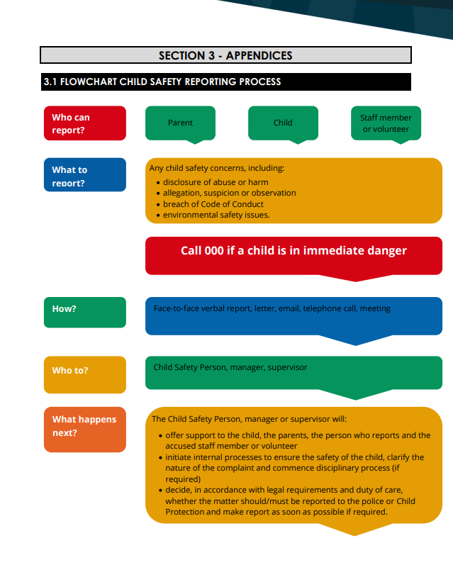
Reviewed October 2025

